San I Seniors Hopped into Spring 2023!

TUNYO PIN PROGRAM APRIL/MAY 2023 NEWS
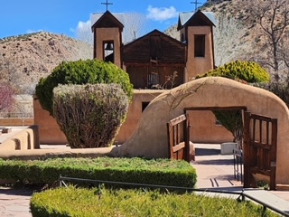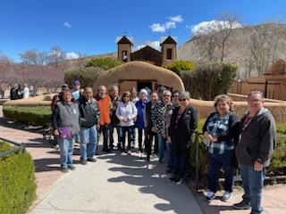
-Wednesday, April 5, 2023: – Tunyo Pin Program made our pilgrimage Holy Week to Santuario. Seniors shopped at nearby stores and then on to an awesome lunch at Rancho de Chimayo. Checked out the Chimayo weaving stores located in nearby. Great Spring Outing was enjoyed by all.  -Tuesdays, April 4,11,18, and 25, 2023, @10:00am. Seniors join in to learn basic crochet stitches. Thanks to our volunteer Eva Lymon, from Los Alamos that donated her time and knowledge. New learners are welcome along with seasoned crocheters. Please join us!  -Friday, April 14, 2023 @03:00pm – Dinner/Bowling Tunyo Pin program participants went to “The Ranch House”. San I seniors filled their tummies and rolled out like stuffed bowling balls. Onto “The Alley” at the DeVargas Mall, two lanes full of San I senior bowlers! All cheered us on. Great participation, it was great to see all encouraging one another. Great strikes, spares and of course the occasional gutter ball. Sore arms/legs the following day but it was worth it. SAN I SENIORS SURE KNOW HOW TO ROLL!  Wednesday, April 19, 2023 @5:30pm – Tunyo Pin Meeting at the Senior Center Conference Rm. Guest Speaker: Troy Campbell/San I Health and Wellness Services. An extra-long meeting with Great shared information with a break for cherry pie & carrot cake to celebrate April Senior Birthday’s. We also were treated to salad from Linda Martinez ENIPC. Kunda Linda!  Thursday, April 20, 2023 @9:30am –Tunyo pin program ventured out to the School of Advanced Research (SAR) in Santa Fe. Was an amazing time spent looking at various arts from Program provided lunch at Pantry Dos.  The Tunyo Pin Program would like to extend a Happy Mother’s Day to all our Seniors. Whether you’re a mother to a child, close aunt/mom, fur pet mom, etc. Enjoy your day and Blessings to you all on this Special Day! Be Safe.  NEXT APRIL EVENT::  Thursday, April 27, 2023 – Tunyo Pin Program to the NATI Pow Wow held at the Isleta Resort/Casino. Program will provide transportation. Leaving Senior Center at 2:30 pm – approx. 6:30pm(?). Please test message Renee Roybal at (505)670-7778 to sign up and please leave voice/text message. Thank you  Friday, APRIL 28, 2023 - after breakfast ENIPC program to have Coin Bingo. Come join in on the fun.  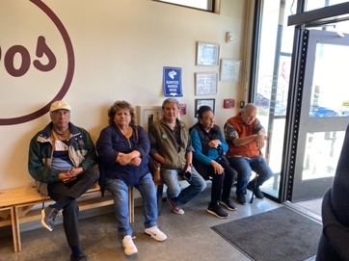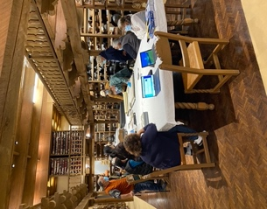  Tunyo Pin seniors spent all morning at SAR, followed by lunch at Pantry Dos. Kunda to our driver John and to our other drivers for other events. Daryl Martinez and Claudene Martinez we appreciate your service to us. 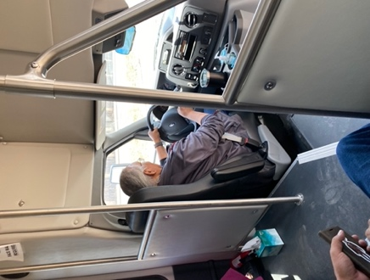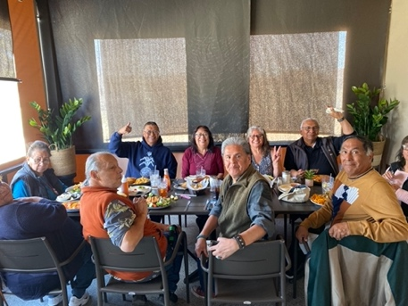 |  | Seniors reflected upon the Lenten/Easter Enjoyed a lunch at Rancho de Chimayo and visiting local Weaving shops.  !  Dinner at the Ranch House, followed by Bowling! High sores by two seniors. Leon Roybal and Sophia Calabaza. Over hundred!

Tunyo Pin Program Upcoming May 2023 Happenings

-Mondays, May 1, 8, 2023 – 10:00am. – Monday, May 15, 2023 @12:30 after lunch. Crochet classes Monday in the month of May at the Senior Citizens center conference room at 10:00am. San Ildefonso Pueblo Seniors 50+ new and seasoned crocheters are all welcome! Volunteer Eva Lymon from Los Alamos is our teacher. We will begin a small project. Black leggings for women.
-Monday May 8, 2023 – Craft Evening with Evon Martinez at Senior Citizens Center @6:00pm.
-Tuesday, May 9, 2023 – Presentation with Raymond Martinez/San I Environmental Dept with colleagues at 10:00am at San I Senior Center. (follow-up mtg from past meeting)
-Wednesday, May 10, 2023 – Mothers Day Invite to Santa Clara Senior Adult Day Care at 11:00am. Will have BBQ and Bingo. (Donations are welcomed) Come sign up and enjoy our fellow seniors from the area. Plenty of Bingo prizes!! Call and leave text message with Renee Roybal to sign up at (505)670-7778 or Royblanet1@gmail.com (Senior bus will leave center at 10:30am)
-Monday, May 15, 2023 @10:00 am – Tunyo Pin Monthly Meeting, at the Senior Center Conference Room. *Please note change* (Chair (Renee) on travel Wednesday)
-Monday thru Friday May 22-26, 2023 – Pottery Mica Class at Tunyo Pin Senior Center at 9am-11am. Introduction First class on Monday, May 22, 2023, discussion on times and class schedule for week. Will be making small micaceous pot. Building, water scraping, sanding, polish and firing on last day. Eight (8) students allowed. Currently 5 students are signed up. Please Call and leave text message with Renee Roybal to sign up at (505)670-7778 or Roybalnet1@gmail.com
-Thursday, May 25, 2023 – NMICOA 1st Quarterly Meeting to be held at Isleta Casino. Meeting from 9:00-3:00pm. All San I seniors are encouraged to attend. Tunyo Pin program will provide transportation. Please call and leave text message with Renee Roybal to sign up at (505)670-7778 or Roybalnet1@gmail.com
-Friday, May 26, 2023 – after breakfast lunch program ENIPC will have Coin Bingo. Come join in on the fun. Empty your pockets for loose change and double your change!

