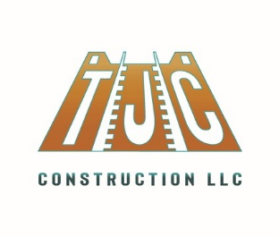
Job Opportunity
CONSTRUCTION LABORER

Job Title Pay and Benefits Job Type
Construction Laborer $15.00 - $16.00 per hour Full-time, Temporary
Job Description
TJC Construction, LLC. is currently hiring for hardworking, motivated experienced construction workers in the role of Construction Laborer. Candidates must be able to work in a fast-paced environment. Individuals will be working an 8 hour day, 5 days a week, in a positive environment and must possess basic knowledge of the construction field. If hired, you will be an integral part of our crew here in the Southwestern U.S.

Responsibilities:
- Maintain all safety standards;
- Assist contractors and tradespeople on the worksite;
- Remove debris and trash from work site;
- Clean up and prepare the job site for the next working day;
- Handle and transport materials and equipment;
- Operate power tools and machineries such as forklifts, levels, power drills, grinders, saws, pressure washers, and more;
- Load, transport, and unload tools, materials, and all other necessary items according to instructions;
- Perform different types of manual labor as needed on the job site.
Applicant Requirements:
- Ability to meet the physical requirements of the job (standing for extended periods and lifting heavy loads);
- Previous general labor experience preferred;
- Good mechanical skills;
- Experience with hand tools, power tools and machinery;
- Strong work ethic and positive attitude;
- Ability to work both independently and in a team environment.
To Apply:
Interested individuals can obtain an application for employment by emailing HR@Keresnm.com.

